Assignment -3

|  |  |
| --- | --- |
| Student Name | ASHRITHA S |
| Student Roll Number | 7376191CS128 |
| Team ID | PNT2022TMID01433 |

**Question-1:**

create a bucket in ibm cloud storage

**Solution**

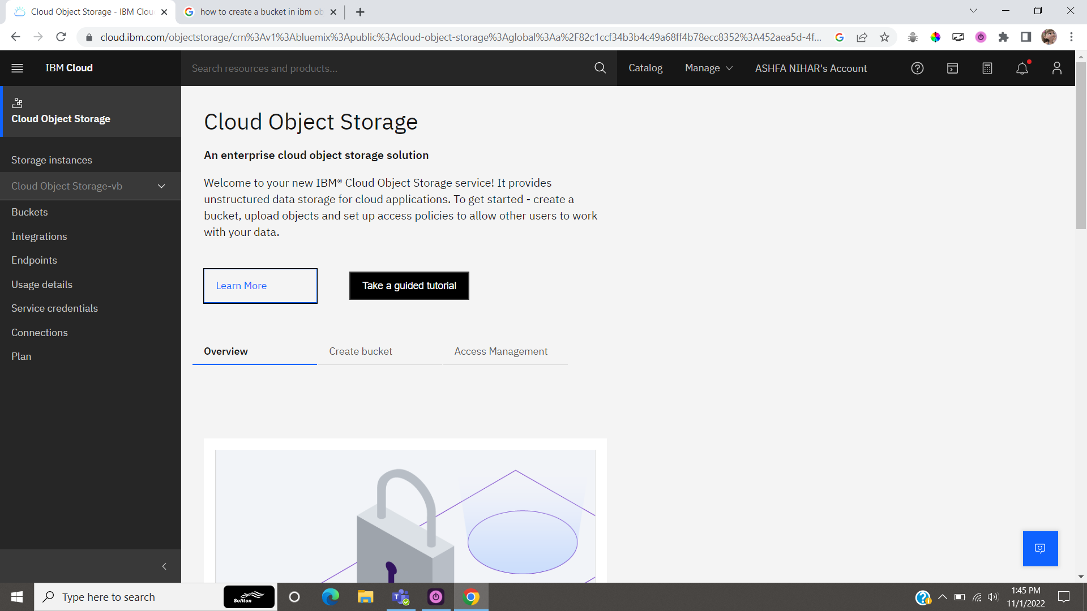

**Question 2:**

Upload 5 images to ibm storage and write html code to display it.

**SOLUTION:**

**Website:**

**INDEX.HTML**

<!DOCTYPE html>

<html lang="en">

<head>

<meta charset="UTF-8">

<meta http-equiv="X-UA-Compatible" content="IE=edge">

<meta name="viewport" content="width=device-width, initial-scale=1.0">

<title>photo-collage</title>

</head>

<body>

<div class="photo-flex">

<div><img src="1.jfif"/></div>

<div><img src="2.jfif"/></div>

<div><img src="3.jfif"/></div>

<div><img src="4.jfif"/></div>

<div><img src="5.jfif"/></div>

</div>

</body>

</html>

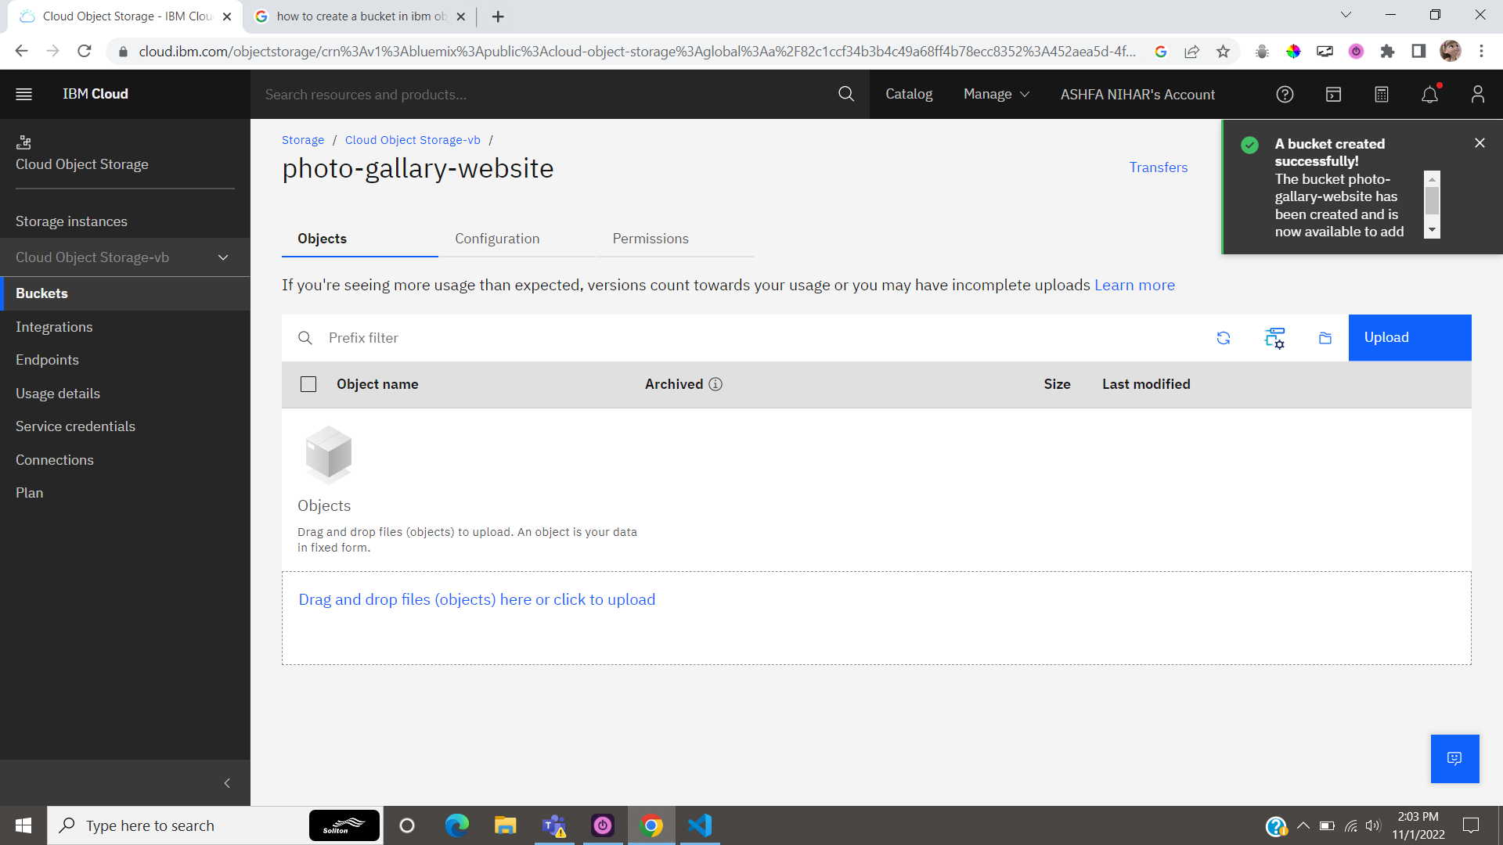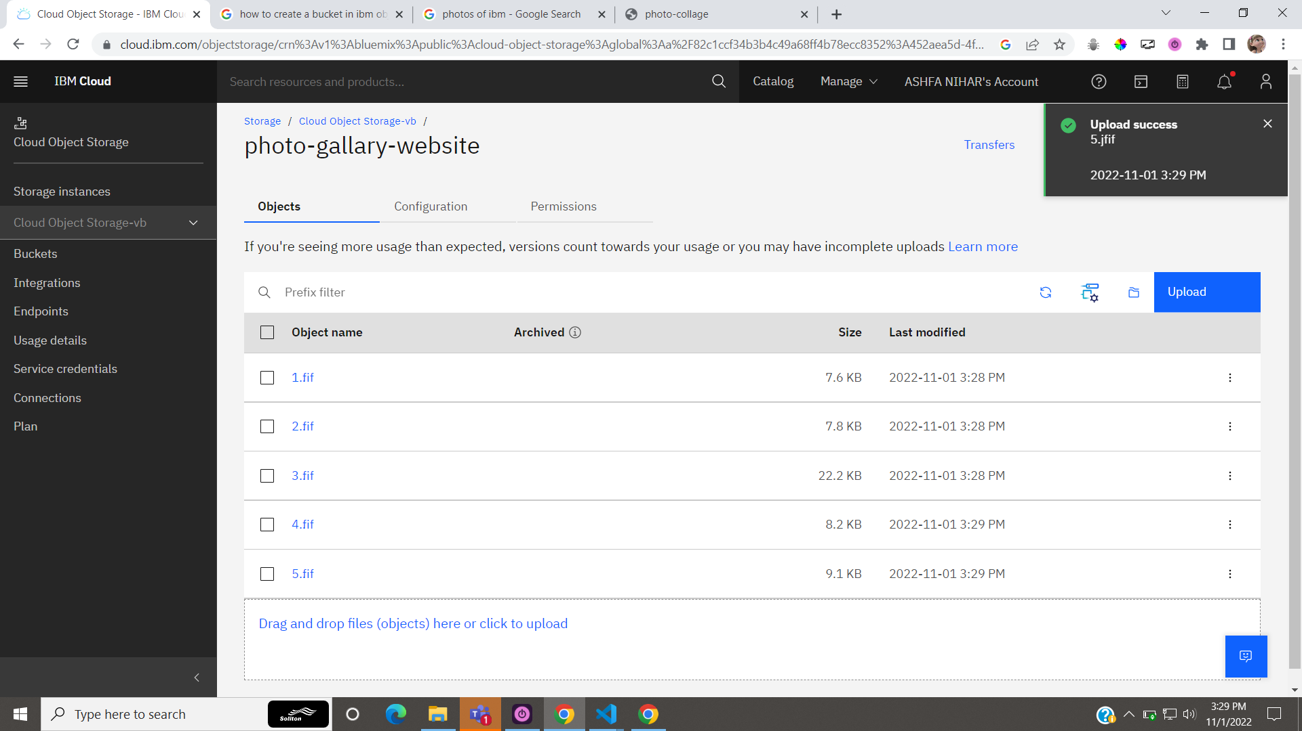

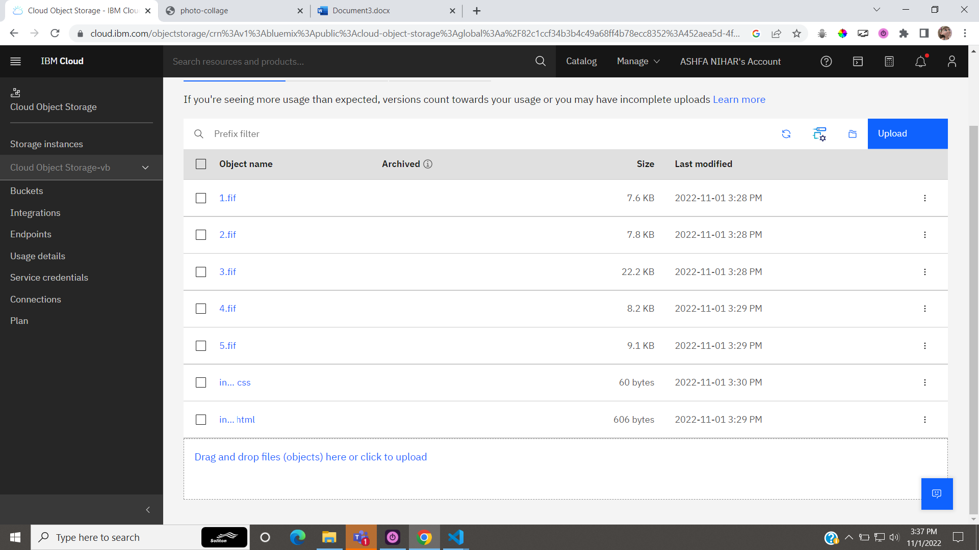

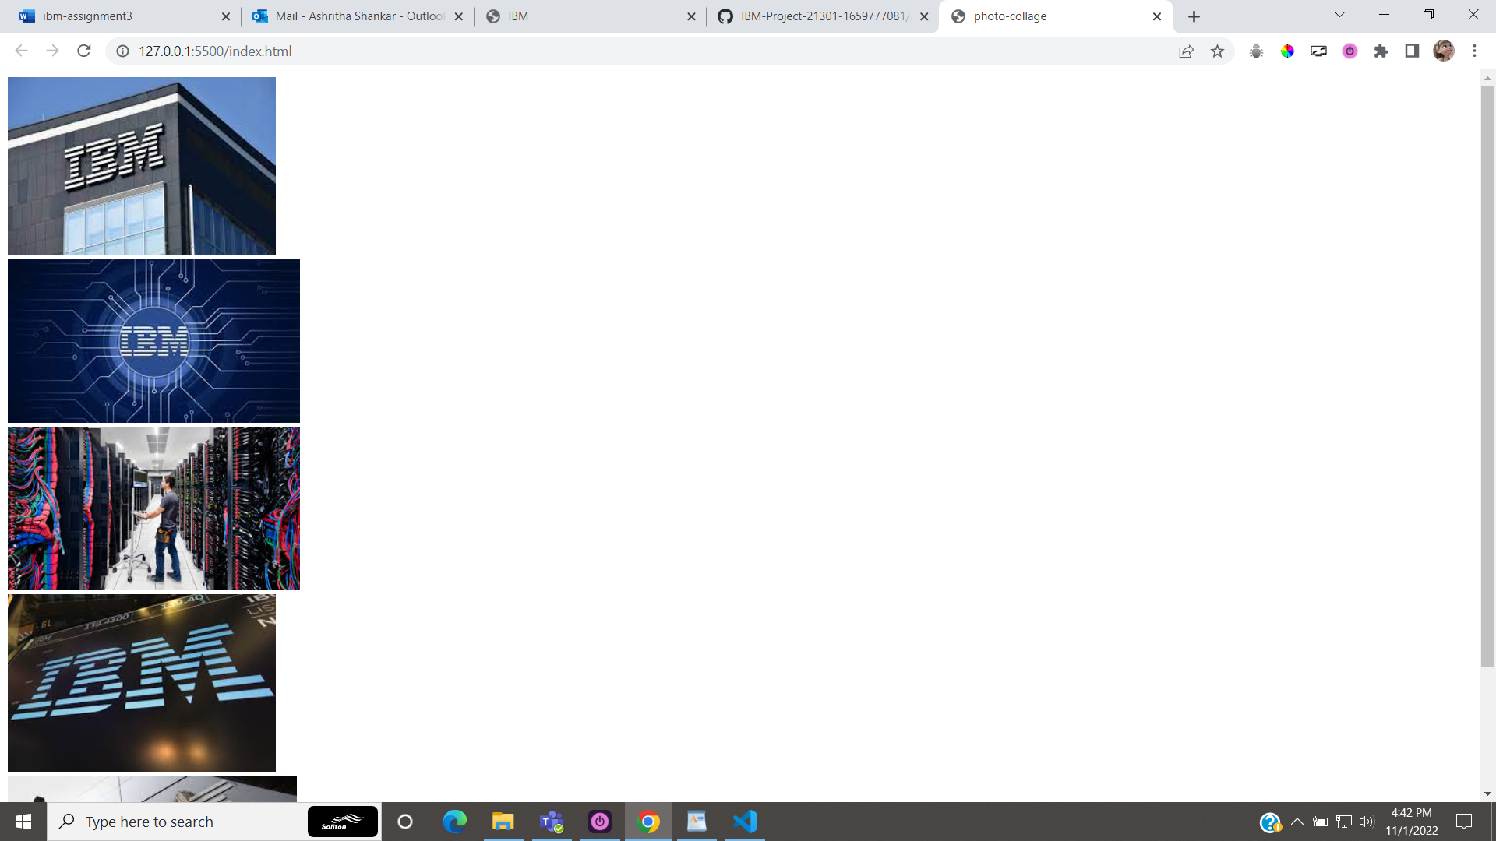

**Question 3:**

Upload a css page to the object and use same page in html code.

**SOLUTION:**

**INDEX.CSS**

.photo-flex{

display:flex;

flex-direction: row;

}

**INDEX.HTML**

<!DOCTYPE html>

<html lang="en">

<head>

<meta charset="UTF-8">

<meta http-equiv="X-UA-Compatible" content="IE=edge">

<meta name="viewport" content="width=device-width, initial-scale=1.0">

<title>photo-collage</title>

<link rel="stylesheet" href="index.css">

</head>

<body>

<div class="photo-flex">

<div><img src="1.jfif"/></div>

<div><img src="2.jfif"/></div>

<div><img src="3.jfif"/></div>

<div><img src="4.jfif"/></div>

<div><img src="5.jfif"/></div>

</div>

</body>

</html>

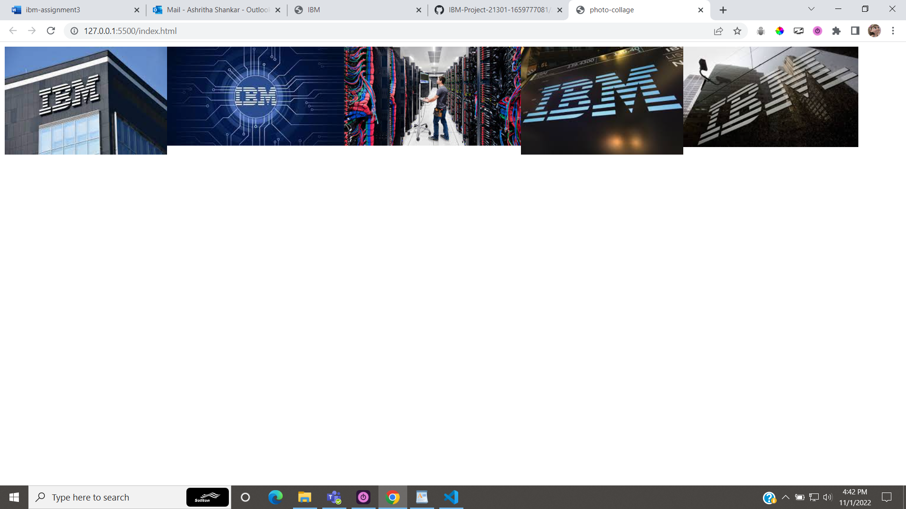

**QUESTION 4:**

Design a chatbot using ibm watson assistant.

**Solution:**

Chatbot:

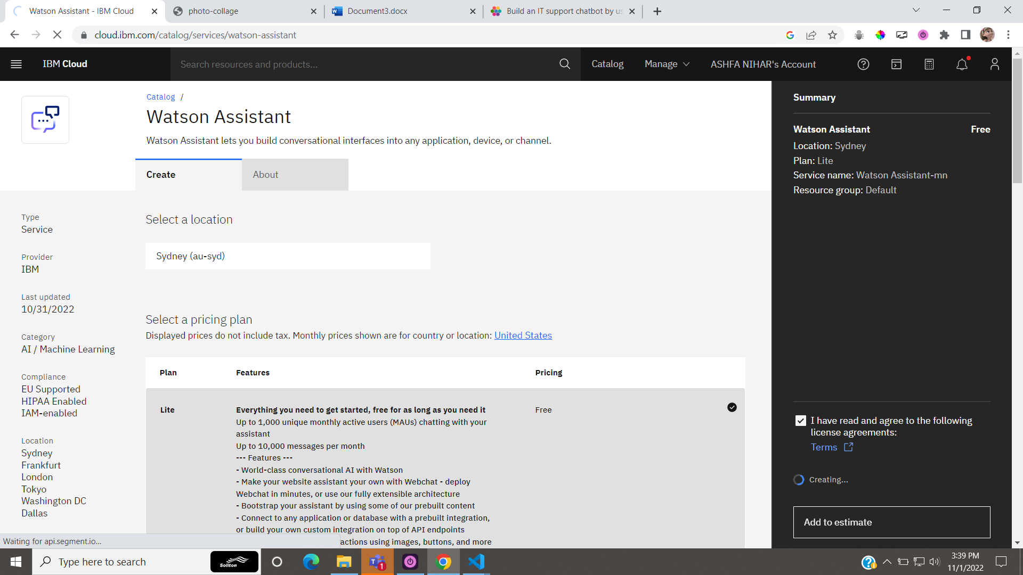

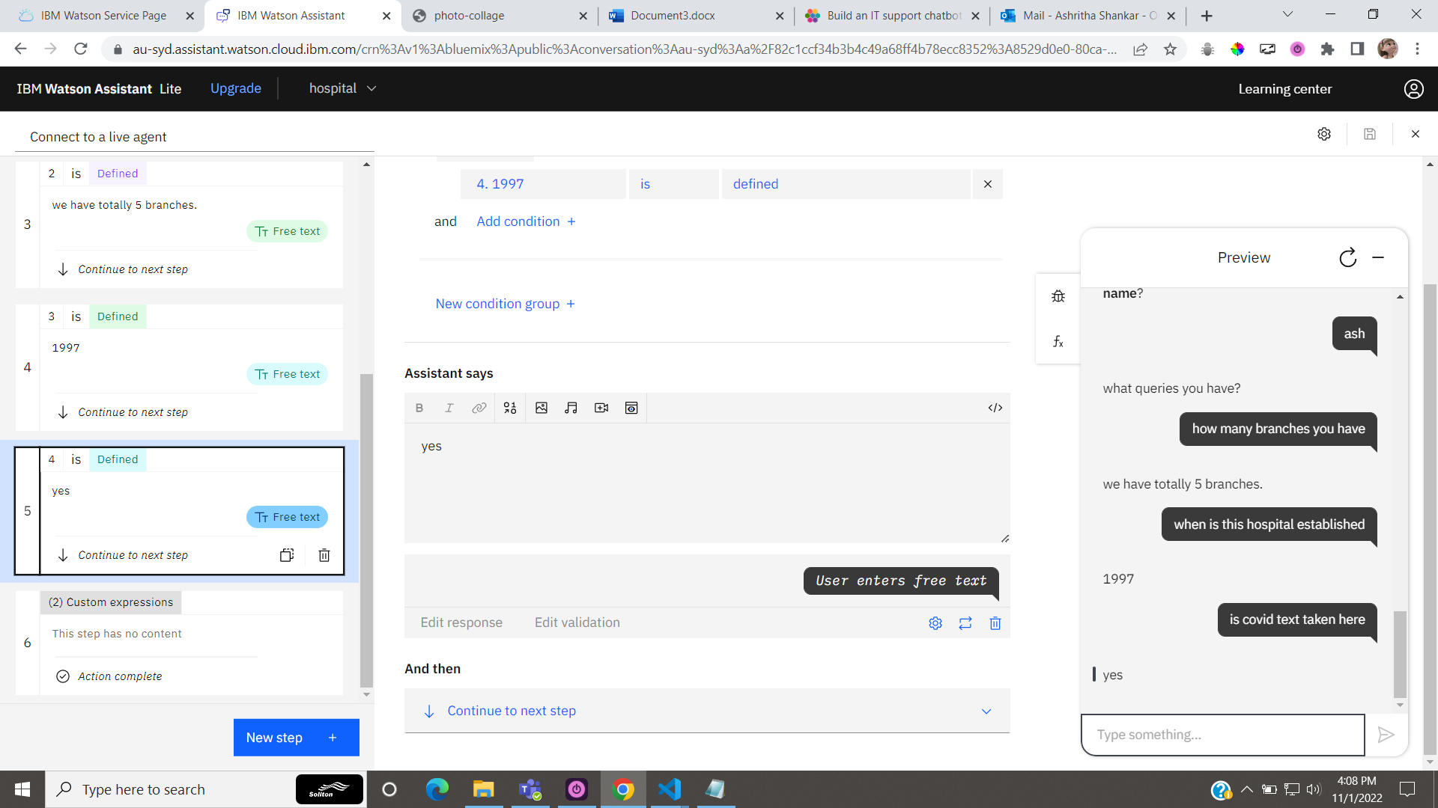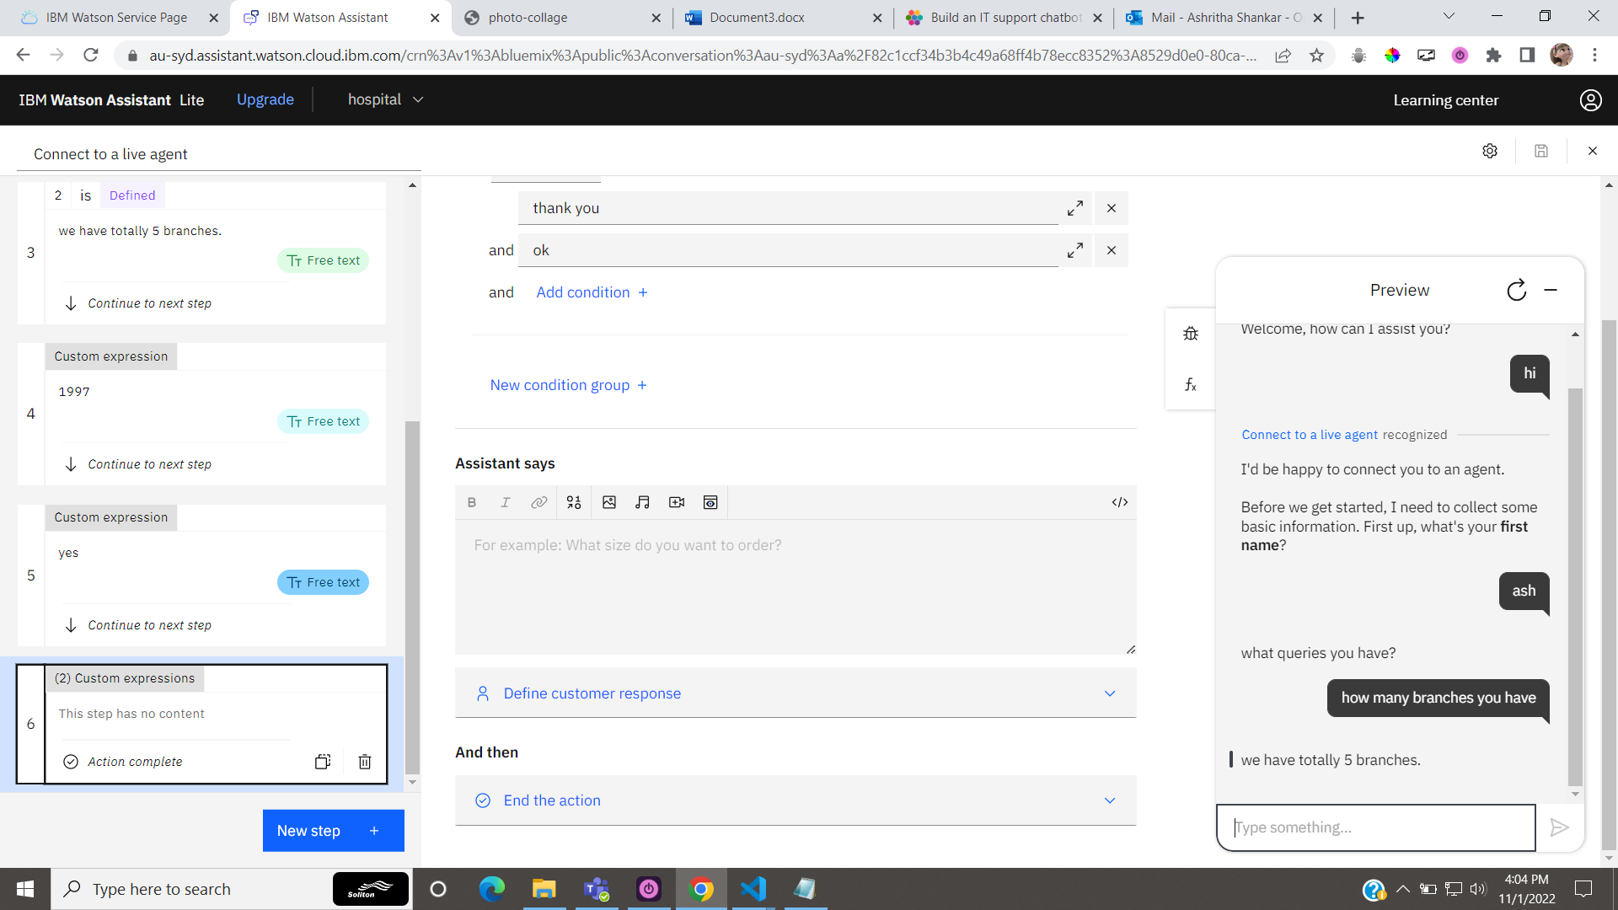

Link to chatbot:

<https://web-chat.global.assistant.watson.appdomain.cloud/preview.html?backgroundImageURL=https%3A%2F%2Fau-syd.assistant.watson.cloud.ibm.com%2Fpublic%2Fimages%2Fupx-8529d0e0-80ca-4e4f-86a0-f46aba8cc5c8%3A%3A538a24e3-b38b-46a6-9f8f-219d5ef9112f&integrationID=483e49ea-3311-4a60-acde-203f58fafc8b&region=au-syd&serviceInstanceID=8529d0e0-80ca-4e4f-86a0-f46aba8cc5c8>

**QUESTION 5:**

Load that script in html page

**Solution:**

Embed it with website:

<!DOCTYPE html>

<html lang="en">

<head>

<meta charset="UTF-8">

<meta http-equiv="X-UA-Compatible" content="IE=edge">

<meta name="viewport" content="width=device-width, initial-scale=1.0">

<title>photo-collage</title>

<link rel="stylesheet" href="index.css">

<script>

window.watsonAssistantChatOptions = {

integrationID: "483e49ea-3311-4a60-acde-203f58fafc8b", // The ID of this integration.

region: "au-syd", // The region your integration is hosted in.

serviceInstanceID: "8529d0e0-80ca-4e4f-86a0-f46aba8cc5c8", // The ID of your service instance.

onLoad: function(instance) { instance.render(); }

};

setTimeout(function(){

const t=document.createElement('script');

t.src="https://web-chat.global.assistant.watson.appdomain.cloud/versions/" + (window.watsonAssistantChatOptions.clientVersion || 'latest') + "/WatsonAssistantChatEntry.js";

document.head.appendChild(t);

});

</script>

</head>

<body>

<div class="photo-flex">

<div><img src="1.jfif"/></div>

<div><img src="2.jfif"/></div>

<div><img src="3.jfif"/></div>

<div><img src="4.jfif"/></div>

<div><img src="5.jfif"/></div>

</div>

</body>

</html>

